Hotel Room Technologies

[Name]

[ID]

[Submission]

# Abstract

With the passage of time, technological changes have brought new challenges for the firms especially in hospitality industry, and now many hotels are willing to take these technologies for supporting their developments in a short time period. This research investigates some of the best technological platforms which should be adopted by the companies in hospitality industry when it comes to managing the customer in their hotels. The results have been completed in the context of qualitative research methodology which is content analysis. This method helped in understanding the latest technologies and finding the best available technologies in room. These mobile apps perform several functions for the customers as well as for the management teams to make their life easy and memorable customer experience. Some of the latest technologies which can be used by the management of other hotels include room service apps, wine on demand, personalised messages right within the rooms, HD and voice controlled thermostats, and service robots.

Contents

1. Abstract 2

2. INTRODUCTION 5

2.1. Applied project Structure 6

2.2. Aim and Objectives 6

2.2.1. Research question 6

2.2.2. Objectives 7

3. LITERATURE REVIEW 8

3.1. Different types of technologies available to be used in rooms 8

3.2. Role of technologies in shaping the purchasing intentions in hotels room 9

3.3. Reasons for adopting AI 13

4. METHODOLOGY 16

4.1. Data Used 16

4.2. Methods and techniques 16

4.2.1. Ethical considerations to increase validity and reliability 17

5. Results 18

5.1. Overview 18

5.2. Customer experience in rooms 18

5.2.1. Digital TV/Satellite in Aysberq Resort 18

5.2.2. QR scan code facilities for room service in Mandarin Oriental, Bangkok 19

5.2.3. Wine on demand in Pillars House Chiang Mai, Bangkok, Thailand 20

5.2.4. HD Voice Controlled & Touch Screen Thermostats in Double Tree By Hilton Hotel Dubai - Jumeirah Beach 21

5.2.5. Personalised experiences by using social media in BEATUS Wellness- & Spa-Hotel 22

5.2.6. Service Robots available in Hotel EMC2, Chicago, USA 23

5.2.7. AltiusPAR's Booking Engine & MoodPad tablets at CitizenM, Amsterdam 24

5.2.8. Marriot City Centre – Charlotte, USA 25

6. Discussion 26

6.1. First aspect - technologies in services 26

6.2. Second aspect – Role of internet 26

6.3. Summary 27

7. Conclusion 28

7.1. Recommendations 28

8. References 29

# INTRODUCTION

The management of an organisation can suffer from a number of issues when it does not adopt new technologies or when it is facing intense competition from others. With the passage of time, technological changes have brought new challenges for the firms especially in hospitality industry, and now many hotels are willing to take these technologies for supporting their developments in a short time period. Due to this reason, the performance of hotels is now depending on providing their customers with best platforms of attracting the customers, and technology is the best support for them. Some of the latest technologies in the market have been observed in the context of Artificial Intelligence domain (AI) because many nations are willing to adapt to them for improving their performance and meeting the business objectives easily.

Voice activated speaker system and chatbots assistants can now be found in large hotels where different people belonging to elite class stay. According to the research article of Melian- González and Bulchand-Gidumal (2016), these devices which are now available to the hotels carry the capabilities of handling the customers easily and providing the best service and monitor home security. These devices can allow booking of appointments, and monitor our home security, create shopping list and play music through voice instructions. These technological platforms allow the management of hotels to ensure that right approach is deployed when dealing with the customers and generate their positive reviews. However, this had made it even more difficult for new and small hotels to remain competitive and showcase their customers what they are capable of. According to Almomani et al., (2017), the management of hotels need to ensure that they use these technologies because soon enough it would become important for them to use these technologies and generate positive customer feedback.

In the last 20 years, technology has rapidly evolved, and only those hotels willing to introduce new technologies for improving customer experience have been able to generate beneficial results. In an investigation presented by Bahar et al., (2019), it is argued that new technologies will be automating service provision in hotels because in future receptions would be controlled by robots instead of women or men. In addition, it is observed on big tourism destinations that performance of the hotels in future would depend on adopting the right technology, which should be better than the competitors. Due to this reason, this research investigates some of the best technological platforms which should be adopted by the companies in hospitality industry when it comes to managing the customer in their hotels.

## Applied project Structure

This thesis is segmented into six different chapters which are structured in the following manner.

In chapter 1, the project presents background to investigation, by providing a brief history to the topic, problem which is under investigation, research objectives, and question.

In second chapter the available literature on the topic is analysed providing an understanding of different performance variables which are contributing to hospitality industry. This chapter is supported with new research articles and their arguments with respect to topic.

The third chapter is methodology chapter which provides the understanding of methods used for investigation, reasons behind them and how results were generated by using those methods.

Chapter 4 is findings chapter, where all the findings are reported in numerical forms, such as graphs, bar charts, regression and correlation analysis. this chapter is most important because it provides the understanding of results which are obtained in this investigation.

Chapter 5 is discussion chapter where results obtained in this investigation are compared with other investigations on the same topic. The studies selected for discussion are not older than 5 years, because it might influence reliability and validity of the findings.

Chapter 6 is conclusion and recommendations chapter, where findings are concluded. In this chapter summary of all the chapters can be found, such as why this study was done, how it was done and what are the results obtained. In the end, recommendations are given to hotels for improving customer experience by adopting best technologies.

## Aim and Objectives

The aims and objectives of an investigation are the most important section of an investigation which allows an investigator to remain on track and carry out research with purpose. This investigation aims to evaluate how technology is being applied by hotels in room for improving customer experience. For this purpose, below objectives and questions have been developed.

The research questions under investigation in this investigation are:

### Research question

1. What are the best technologies applied to the enhancement of customer experience in the room?
2. Whether hotels use these technologies for enhancement of customer experience or not?
3. What are the challenges associated with use of these technologies to enhance customer experience in hotels?

### Objectives

* To find out the new technologies applied to the enhancement of customer experience in the room.
* To check whether hotels use these technologies for enhancement of customer experience or not.
* To evaluate the challenges associated with use of these technologies to enhance customer experience in hotels.

# LITERATURE REVIEW

This chapter is considered the most important in terms of providing information with respect to other studies, and what they have to say about the topic. In this chapter some important and most used technologies are discussed with respect to hotel industry, and how organisations should be using them to attract the customers.

## Different types of technologies available to be used in rooms

One of the most used technologies nowadays in hotel rooms is Smart Hotel Lighting which is only available in some lavish hotels. According to the research article of Wu and Cheng (2018), the management of different hotels is using this technology because getting up late at night in hotels in a strange hotel room can be challenging, because a person does not know where he is. That is where this smart technology comes into play. The findings of Pereira-Doel, Font and Howarth (2018) reported that management of Accor Hotels just introduced their smart lighting rooms, which are supported with smart motion sensors, and lights installed beneath each bed and throughout the room. Its image can be found below:

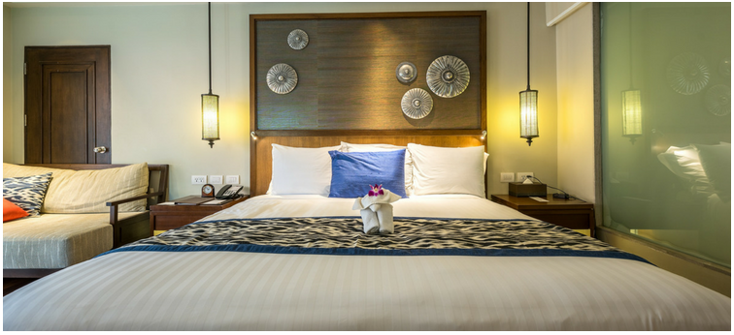

Figure 1 smart lighting

This hotel technology is not under use by many hotels, because it is pretty new, and currently this system is supported by Philips Hue App, which can easily synchronise with room’s lighting.

Another important technology which is under use by the hotels is Hotel Tablets, which is now allowing the tourists to get social. Bharucha and Fukey (2017) reported that this tablet allows the guests to get social, without leaving the rooms, and by competing in different trivia competitions, across the nations. Supporting the argument, Khattab and Elsayed (2018) argued that national trivia competitions now take place 15 hours a day and 7 days a week they are now just a tap away of people who want to play. Hence these tablets have resolved the issue of getting social because it is allowing the management of different hotels to receive the reviews of customers and ensure that best results are achieved.

One more important innovation made in this field is Smart TVs, which have allowed the management of different organisations to ensure that best results are achieved. In an investigation of Azis, Muhibuddin and Saleh (2018), it was reported that some business travellers are watching Netflix on their smart TV and suddenly they receive a call. With the help of these smart TVs, they can receive their call on their TVs and can seamlessly watch movie and receive calls at the same time. On the other hand, Makinen (2016) reported that technology has gone more forward. Now hotel tablets have the power of turning your TVs into customizable signage. This signage allows the guests to remain intact with their business schedules, and enjoy their trip also.

Now people can also use App-controlled doors and digital do not disturb mode. In an investigation of Salih (2017) and Duan et al., (2019), it was reported that sometimes people are not willing to take room service, because they either are enjoying their good time with their honey or watching Netflix with their wife. In this situation, instead of getting up from their beds, they can easily unlock their doors from smartphones. However, Choo and Tan (2019) reported that this technology is not available in 80% or more hotels all around the globe and will take a lot of time to come. Due to this reason, I would like to say that there are numerous opportunities available to the management of these organisations because Pool et al., (2018) reported that new hotels can make use of this technology so that they can attract more customers. Hence this technology carries a lot of potential for the hotels in future.

According to Tang (2018), hotel and room services with the use of technology in future would become a challenge, because with so many emerging technologies coming in this world, it would be a challenge for the hotels to select the best one of them. Hence, these technologies can prove to be of significant importance in future for the hotels, especially, when they are willing to sustain their competitive advantage for a long time.

## Role of technologies in shaping the purchasing intentions in hotels room

The field of AI is vivaciously developing these days, with more scientists attempting to examine the effect of such innovation in the lodging. Industry specialists look to discover how AI can upgrade their client experience, so as to yield higher client steadfastness and consequently higher benefit. This segment will analyze increasingly past examinations about the innovation of AI, client experience, and the connection between them (Ezrachi and Stucke, 2017). AI has been appeared to significantly diminish the requirement for human help with regards to replying questions (attributable to an immense vault of data, both inward and outer, at their computerized fingertips,) and settling issues that usually emerge during a visitor remain. A few driving lodgings bunches report that their AI enabled attendant services, noting visitor questions by the content or potentially voice, have decreased calls to the human attendant work area by 35 percent or more, liberating partners on the property from routine undertakings (Moreno-Izquierdo et al., 2018). "As opposed to stress that more prominent dependence on innovation will dissolve the human part of neighborliness, hoteliers need to grasp it for what it tends to be, an important apparatus to all the more likely comprehend their visitors and arrange remains that they will long recall," said Jay Upchurch, Vice President, Oracle Hospitality. "Innovation can address the business' double test of working effectively at scale and at the same time offering individualized assistance."

As per explore led for this investigation, a normal of 71 % of visitor demands are currently taken care of consequently by AI-empowered reaction innovation in lodgings where the frameworks have been executed (Bar 2018). The outcomes as far as time investment funds, cost reserve funds, and visitor relationship upgrade make for a solid business case for putting resources into inn innovations that outfit the intensity of computerized reasoning. However, yet in its early stages, AI has more than validated its incentive with regards to inn visitor administrations. Hotels visitors have generally expected a consistent and frictionless experience all through their stay with resources. They expect exceptionally quick reactions to their requests to the front work area, for instance, regardless of whether those reactions are created by a human or by a propelled discourse empowered IVR administration. In all actuality, an enormous level of individuals today really wants to associate with a machine, given the decision. As indicated by late overviews, 41 % of American web clients’ today state that they would prefer to utilize advanced client administrations than address a human CSR on the telephone (Kang, 2016). In an inn setting, that inclination perhaps higher. Almost all fragments of lodging visitors are currently sensibly OK with utilizing visitors confronting advancements. Indeed, even visitors who typically prefer to interface with inn staff are regularly glad to enlarge those cooperation’s with innovation alternatives.

Recent college grads, specifically, who currently represent almost 76 % of all inn visitors, expect nothing not as much as cutting-edge stages, applications, and interfaces (Ko, Chan and Wong, 2019). Spending a normal of $4,000 every year on movement, they occupy a continuously on innovation condition (Munger, 2016). Cell phones, tablets, workstations, and voice-initiated speakers are their consistent friends all through the course of their day. The visitor administration desires for Millennials will, in general, be particularly high in an accommodation domain, given the intrinsic guarantee of unrivaled visitor benefits that is the foundation of upscale inns and resorts. Many hotels claim that AI reduced the problem-solving time and increase the guest experiences and this percentage is increasing with time. Many hotels must choose the option to move quickly toward the path of visitor personalization, there is need to not just met the visitor desires however, to likewise keep up serious equality. Some level of visitor personalization is rapidly turning out to be table stakes, the base bet that lodgings need to put on the table just to remain in the game. In past years, numerous inn bunches have put vigorously in making increasingly novel and separated physical spots, including updated visitor rooms with the most recent solaces and pleasantries, some of which are innovation empowered. Presently the center has moved to give visitors uncommon and significant stay encounters empowered through the intensity of personalization.

76 % of the hoteliers are strongly agreed that the artificial intelligence increase the visitors experience in their journey (Abaeian et al., 2019). 88 % of hoteliers "concur" or "emphatically concur" that focused personalization i.e., giving visitors profoundly important messages, offers, and administrations at the ideal time is one of the best approaches to improve the visitor experience and, eventually, visitor fulfillment, dependability, and ideal brand support (Abaeian et al., 2019). As AI moves from trendy expression to utilitarian reality in the accommodation division, it appears to be everything except sure that it will play an undeniably a significant job in helping inn administrators focus on the various components of the visitor excursion, screen, and survey execution, and banner weaknesses that should be tended to. At times, it might even purpose issues without the requirement for human mediation and furthermore recommend new developments to improve visitor fulfillment. Today 83 % of hoteliers refers to the capacity to "catch information from which hoteliers can produce significant bits of knowledge for improving business forms also (Deraman et al., 2017), driving advancements that further upgrade the visitor experience" as a top the advantage of an AI innovation activity. Certainly, hoteliers accept that man-made consciousness is digging in for the long haul and that the advancement of related advancements will continuously improve the general visitor experience.

88 % of hoteliers concur that AI fundamentally decreases working expenses in the client service work (Zervas, Prosperpio and Byers, 2017). By incorporating man-made brainpower to reclassify the importance of extraordinary client experience, inns additionally have the chance to build positive brand mindfulness and increment client devotion, which should convert into unmistakable income gains. Simulated intelligence empowered innovation should be made a piece of the general business procedure. Workers should be remembered for the technique and comprehend how they can cooperate with the innovation furthering their own potential benefit as well regarding the benefit of the association in general. Artificial intelligence empowered innovation should be made a piece of the general business procedure. Workers should be remembered for the technique and comprehend how they can cooperate with the innovation furthering their own potential benefit as well regarding the benefit of the association in general.

With regard to using AI, the lodging business was lingering out of date. In any case, as this examination study appears, that is not true anymore, especially concerning the visitor experience. Today the business is moving quickly and angrily toward not just reflecting AI-empowered home and office encounters in visitor rooms however outperforming those encounters with a scope of creative capacities intended to additionally lift the general visitor experience over the whole property and past.

Numerous prevailing writings recommends that diﬀerent consumers may have unalike approaches and intents to interrelate with AI mechanisms because of their point about technical awareness, computer technology assistances, also distress through internet-safety amongst the aspects affecting the intent to utilizing an AI chat-bot (Nadarzynski et al., 2019). Additional research establish which consumers’ height of technical fondness (for example, technology dependency, technical identity, technology bond, and technology social closeness) upsurges the gratification with machinery facilities also reliance inclined on AI facility gadgets inside framework of boarding house service industries (Wu & Cheng, 2018). Moreover, robotic device usage one’s-effectiveness had been retrieved supposedly connected through consumers’ operationally along with generally approval concerning provision mechanical device (Latikka, Turja, & Oksanen, 2019). Supplementary investigation had recognized such clients’ epicurean inspiration also the societal impacts are chief features affecting the assessment of AI facility mechanisms inside boarding house facilities. Lin et al. (2019) examined the backgrounds of boarding house clients’ readiness to utilize AI service automata inside diverse boarding house facility settings. They attained which, equated through further interpreters (societal impact, the anthropism, working anticipation, also endeavour prospect), consumers’ epicurean inspiration is furthermost noticeable aspect which pushes their excitement to AI robotic facilities. parallel outcome has now been likewise originate by a qualitative research, which contended that the chief inspiring features directing Taiwanese consumers to practice AI machine in hotel service are to obtain amusement and fulfil inquisitiveness (Kuo, Chen, & Tseng, 2017). Additionally, preceding findings emphasized the influence of hotel consumers’ societal impact on their conduct to accept AI facility machines (Gursoy et al., 2019; Lin et al., 2019). Writings noticed such consumers who have a great comprehended societal impact of usage of AI service machines are expected to offer the usage of these mechanisms an optimistic assessment (Gursoy et al., 2019). Lin et al. (2019) also discovered which observed societal impact performs a huge significant part once that a consumption choice is recognized as pertaining a lesser amount of significance (against highly significant) by consumers.

When consumers are assessing the usage of AI automata, they are probable to formulate the assessment through specific circumstances. By way of illustration, Wu and Cheng (2018) establish which comprehended threat might balance consumers’ gratification of keen hotel machines and their intent to communicating this lodging undergo on the social platforms. Once the consumer notices the threat connected with operating smart hotel gadgets is elevated, although they are content with the facilities delivered by these hotel gadgets, they are not as much expected to reveal the happening with their networks. Lu et al. (2019) originate that consumers’ believe assisting circumstance definitely connects to their readiness to practice AI robotic gadgets in boarding house provision dealings. The outcome of their research uncovered that the administrative or technical provision from boarding house or automaton inventors could alleviate consumers’ professed disputes related with consuming robotic facilities and can minimalize obstacles for consumers to receive the usage of AI provision machines.

Robot-provision ﬁt is additional serious issue that impacts consumers’ opinion. Ivanov et al. (2018) discovered that Russian grownups are a lot probable to allow a few robotic hotel amenities while discarding others. Such as, they are most approachable concerning the automata which does transference of goods (for instance, transporting suitcases or linens), deliver info (for instance, oﬀering material concerning local travel fascinations), or manage expenses, nevertheless purpose to the usage of automata to offer safety or occupations needing skin interaction (for example, massage). Moreover, Chan and Tung (2019) performed an empirical research that examines a balancing impact of boarding house section (economical, mid-range, or lavish restaurant) on the association amongst robotic facility and consumers’ assessment of staying event. They establish that robotic facilities instigate more influence in the perspectives of economical and mid-range accommodation than lavish restaurants, as provision estimation delivered through the staff automaton is in no way majorly appreciated through lavish guesthouse consumers. Lin et al. (2019) examined consumers’ approval of AI machinelike amenities in end to end service guesthouses and restricted-facilities guesthouses. Their outcomes proposed that consumers’ interactive intents are produced dissimilarly through these 2 service settings. More precisely, they discovered that while assessing robotic facility, full-service guesthouse consumers rely less on societal impact, their complete feeling concerning robotic amenities by far not impacted through work anticipation, and their oppositions are much less probable to be impacted through the feeling concerning an automaton. These indications recommend such consumers’ calls with regards to interface through human workers are steadier in end to end services guesthouses than in restricted facilities guesthouses.

## Reasons for adopting AI

Inside framework regarding facilities, there is a growing drift concerning usage of AI automata to substitute human staffs instead of supplementing them, as demonstrated through automaton bellboys employed inside guesthouses (Gursoy et al., 2019), automatic bartenders (Tung & Law, 2017) or through current (also provisional) innovation of Henn-Na guesthouse with 243 humanlike bionic-person staffs (Hertzfeld, 2019). This drift in the direction of robotic provision managers seems to be determined mainly by financial aspects for example worker reduces cost (Gursoy et al., 2019; Manyika et al., 2013; West, Cliﬀord, & Atkinson, 2018) also societal aspects for example an elderly people (Kuo et al., 2017; Lee et al., 2018a) or might be the drive of increasing low pays (Mcafee & Brynjolfsson, 2016)

Add-on particularly economical also societal aspects, the acceptance of AI machinery and delivers extensive duty-improvement openings (Marinova, de Ruyter, Huang, Meuter, & Challagalla, 2017; Qiu et al., 2019), that are frequently ignored inside “mechanization contrast. employments” argument. Such as, Prentice, Dominique Lopes, and Wang (2019) discovered an influence regarding workers’ emotive intellect also AI of their functioning atmosphere on their work recital. They establish that despite the fact emotive intellect forecasts work recital, the AI of the operational atmosphere can evidently compensate workers who have little emotional intellect, directing to a greater work recital. Inside the framework of medical assistance amenities, Lee and Cranage (2019) establish that facility automata could decrease paramedics’ amount of work through capturing during trinket additional paramedics undertakings for example transferring sheets or vacuuming. Through achieving so, these automata allow paramedics to deliver better attention also improved facilities to people who are effected. Additionally, AI provision gadgets allow facilities to be conveyed at a lesser budget, permitting facilities which were unaffordable to be delivered to consumers causing in better general provision worth (Bowen & Morosan, 2018)

Facilities delivered through AI gadgets could deliver added also exclusive duty worth. Preceding writings discovered that robotic facilities (in opposition to services delivered through individual worker) are vastly related through observable also intelligent involvements (Chan & Tung, 2019). Numerous researches recommends as well that in hotel facilities communication amongst AI automata also consumers creates innovative happenings (Van Doorn et al., 2017; Tung & Au, 2018). Several consumers also search to cooperate through facility automata also discover openings to construct relationship with them (Tung & Au, 2018).

Numerous prevailing researcher discovered as well that embracing AI automata for facilities can also not directly profit the general duty result. By way of illustration, Tussyadiah and Miller (2019) establish that an automaton could perform like a means to impact consumers’ actions that are indirectly linked with the automaton. Applying the philosophy of the watching-eyes eﬀect, their investigation recommends that while machine operator is there, guest house clients are further expected to reveal benefits of the environment actions. Additionally, Pan et al. (2015) discovered that when more than 2 consumers are networking through a provision automaton concurrently, the consumers are probable to network with other clients. Since the following viewpoint, the usage of provision machines might encourage consumers’ societal communication inside settings of guesthouse facilities. Mende et al.’s (2019) research concentrated on consumers’ compensation comebacks aroused by robotic facilities in a dining venue. They assumed that identical to people automata might product inside consumer distress as these automata intimidate their humanoid self. This distress supplementary activates consumers’ the compensation reactions for example food desire. The outcomes of their investigation affirmed this assumption, demonstrating that consumers who are attended by people-like automata (against by people) are expected to order additional meal.

# METHODOLOGY

Methodology section is considered one of the most important sections when it comes to presenting the details of how data was collected and analysed. A number of research methods are available to the researchers for carrying out the research and drawing the conclusion. This research investigation is based on taking secondary research approach and finding out the results in terms of arguments and content analysis. This research has used qualitative data and presented the arguments, by working on the objectives. This research makes use of realism approach and presents the findings by using realism approach. Furthermore, research approach undertaken is deductive because content analysis method is adopted. The research has presented several case studies of hotels and what are the technologies they are using to make customer experience unique. Reason to select this methodology is that it helps in understanding the technological developments which are taking place in hotels.

## Data Used

The data used is secondary in nature, because secondary data is detailed and detailed data helps in understanding the results easily. Furthermore, different features of room technologies have been presented by taking global literature done on the topic and presenting them by adopting comparison methodology. The results have been completed in the context of qualitative research methodology which is content analysis. This method helped in understanding the latest technologies and finding the best available technologies in room. This research is beneficial for those hotels who are willing to integrate new technologies in their hotels, and for the travellers who want to see which hotel is best for them. some of the spatial and temporal characteristics of data obtained are the fact that hotels will be able to upgrade themselves, while travellers would be able to find the best hotels in different cities for tourism. There was no error found in the literature which has been used for presenting the results, because data is collected from authentic resources and websites only to increase validity and reliability of the findings.

## Methods and techniques

The methods used for collection of data is qualitative and presents the findings using the arguments of the scholars and websites featuring the characteristics of hotel rooms. For this purpose, secondary data is considered the best because many people are unaware of the features being offered in the hotel, hence reliability and validity can be compromised. Due to this reason, comparison of 10 different hotels is carried out, which were investigated in the last 5 years. The hotels and their comparison have helped in understanding the developments taking place in hotels. Sampling technique used for selecting data is purposive sampling technique because it helps in selecting the best data from the available links.

### Ethical considerations to increase validity and reliability

Ethical considerations are considered the most important when it comes to analysing the case study, or studies. Since this study is making use of the qualitative method and secondary data, content analysis method was best suited for carrying out the investigation. Some ethical considerations undertaken for this investigation is selecting the right population for investigation, which is 10. In this research comparison of 10 hotels belonging to 4-star or 5-stars only are selected and compared. Reason to select these hotels is because of the fact that research investigations are taking place rapidly, and many hotels have started to post their pictures on social media platforms. Those pictures have been collected online and features offered in those hotel rooms are compared. In addition, only last 5 years data has been taken. The hotels have been selected from different countries regardless of the native nation.

# Results

## Overview

This section of the report provides the results obtained with respect to the research objectives which can be found under the headings below:

## Customer experience in rooms

The customer experience in rooms is changing, and some examples of case studies with respect to technological changes can be observed in the headings below:

### Digital TV/Satellite in Aysberq Resort

Aysberq Resort is a five star resort, which is providing Digital TV and Sattelite to its people. An image of hotel view can be seen in the figure below:

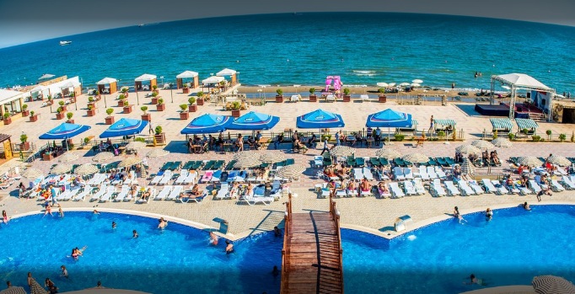

Figure 2 Hotel view

Digital TV and satellite are considered one of the latest technologies which are not available in many hotels. When we searched on Trip Advisor by applying the filter of digital TV only one hotel was found in Baku. The room interior can be observed in the figure below:

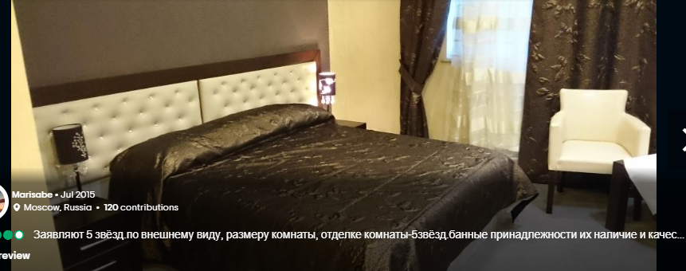

Figure 3 Room interior

The satellite TV can be used by any person who is willing to pay high rent of this hotel. Hence, it can be said that satellite TV inside the room is allowing people to make their time unique, and telephone inside the room is also available to call room service anytime.

### QR scan code facilities for room service in Mandarin Oriental, Bangkok

The management of Mandarin Oriental, Bangkok is providing room service apps to people coming in their hotel. Through this app, people coming in restaurant will not be attending room calls, and they will be required to use this app for calling room service. Through this app, it would be easier for the management to offer web-based services to their customers and ensure that they are able to enjoy their time in hotel. This hotel is located in Bangkok and comes under 5 star hotel category. Some images of hotel rooms can be seen in the figure below:

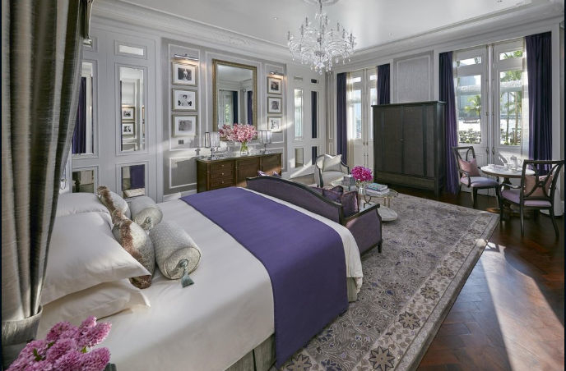

Figure 4 Mandarin Oriental Bangkok

### Wine on demand in Pillars House Chiang Mai, Bangkok, Thailand

This hotel is a five-star hotel, which has recently installed wine units, which are stocked with local, and award winning pours that can be poured into an electronic dispenser into a smart fridge containing water and ice machines. This facility is available inside the rooms because many people do not want to take hassle of calling room service again and again. It is considered a great method of making the customers feel valued and enjoy their rooms instead of just considering it a place to sleep. Hence smart fridges are also considered new technologies which are available to people now.



Figure 5 Interior of hotel

### HD Voice Controlled & Touch Screen Thermostats in Double Tree By Hilton Hotel Dubai - Jumeirah Beach

This hotel is located on Jumeirah Beach in Dubai. This hotel is using HD Voice Controlled and Tough Screen Thermostats, which has built in sensors carrying the power of detecting when someone enters or leave the room. Due to this reason, people can see dim lights when they enter in room. In addition, it is pretty nice to get up in middle of night and shout to these smart tools and they will work for you. Hence, this also adds up on technology infrastructure in hotel rooms making it easy and hassle free for the customers.

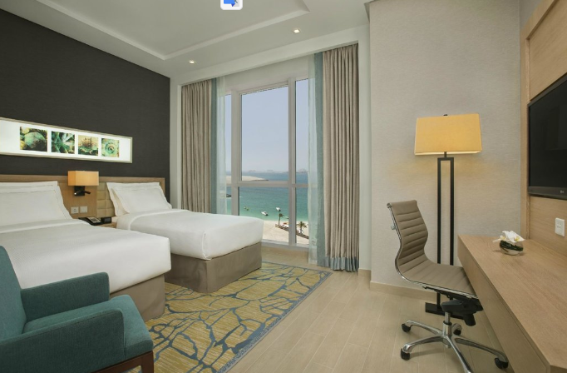

Figure 6 Room in Double Tree By Hilton Hotel Dubai

### Personalised experiences by using social media in BEATUS Wellness- & Spa-Hotel

This hotel is located in Merligen, Switzerland, and it is now providing all the tourists with direct messaging technology through which the customers can connect to hotel staff services without any hassle of any other applications. Hence this technology provides the customers to interact on social media platforms with the staff members and pass them orders if they want to. Hence decreasing hassle of calling the room service again and again.



Figure 7 BEATUS Wellness- & Spa-Hotel

### Service Robots available in Hotel EMC2, Chicago, USA

The management of this hotel is using service robots which can sustain the idea of being good robots, and these robots are allowing the management to divide their workload. The management is using product which is titled as Relay, which looks like rolling bins, and they can easily come to your service via a remote control button. In addition, these robots have replaced room service providers because of their intelligent sensors, and great timely deliveries.

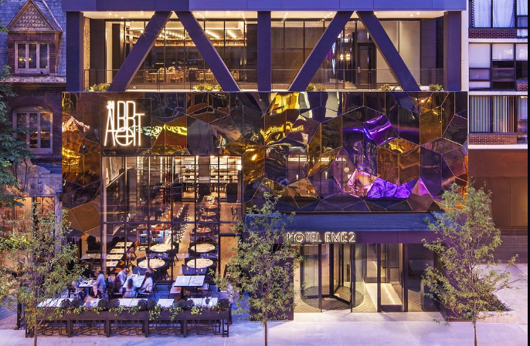

Figure 8 a view of Hotel EMC2

### AltiusPAR's Booking Engine & MoodPad tablets at CitizenM, Amsterdam

This hotel is located in Amsterdam, Netherlands. The management of this hotel is trying its best to provide its customers with excellent services by using AltiusPAR’s Guest Experience Ecosystem (GEE), which also has its Internet Booking Engine that facilitates CitizenM in providing highly automated services to their customers. This Booking Engine helps the guests to easily book their room at the hotel. The hotel has all the guest information and updates through this engine. Guests can choose any TV content of their choice, can adjust room temperature, can change lighting automatically by using MoodPad tablets. CitizenM also offers free Wi-Fi and movies to its customers

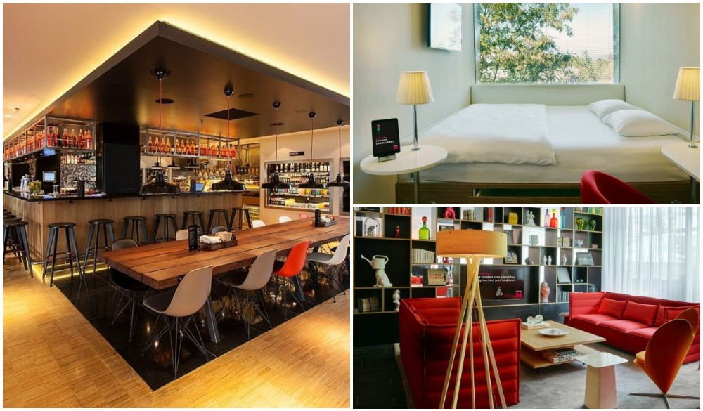

Figure 9 a view of CitizenM Hotel

### Marriot City Centre – Charlotte, USA

This hotel is located in the USA and it offers high technology services to its guests. Check-ins can be made possible through mobile apps. Guests can have all the details related to their check-ins/check outs timings, rate charts, and restaurant details etc. This mobile app also works as a room key for the guest. All the furniture including beds, chairs, tables, etc. all is automatically adjustable. There is also a Fitness on Demand room in this hotel which offers more than 600 programs to the guests to have yoga and HIIT training facilities.

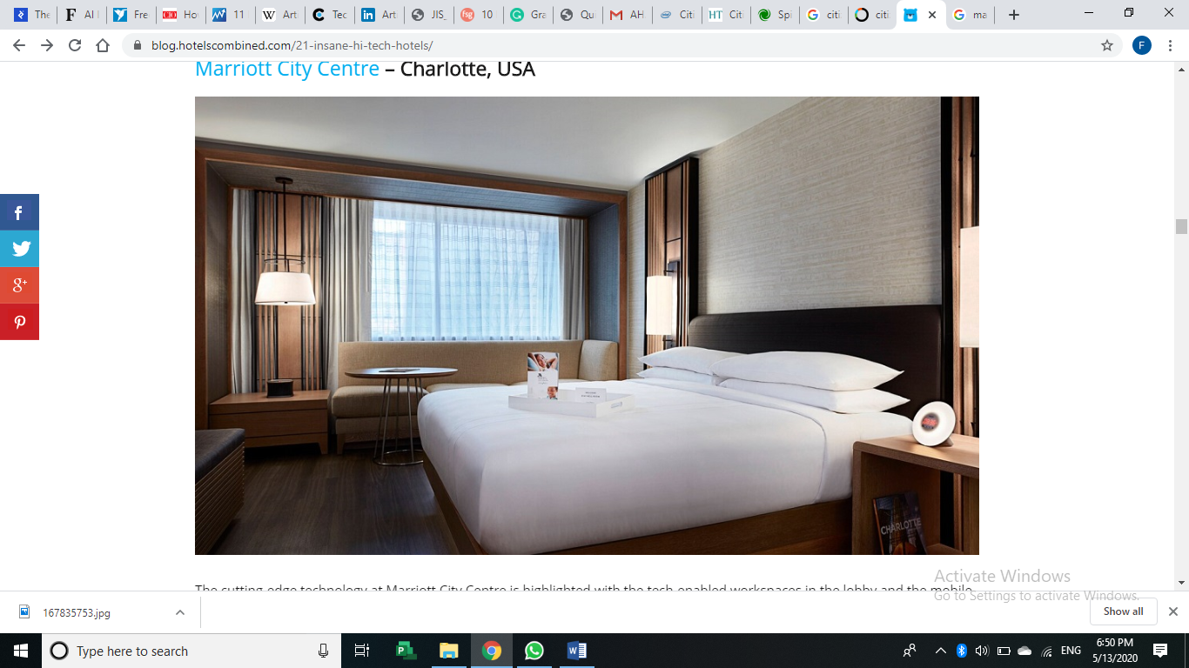

Figure 10 a view of Marriot City Centre

# Discussion

## First aspect - technologies in services

The introduction of an advanced system of technologies in service industries has been proved as a productive and overwhelming change. Nowadays, every type of industry is incorporating technological innovations in their services so that they can attract more customers and improve customer relationships. Choo and Tan (2019) argued that online booking systems, digitally adjustable furniture, use of mobile apps to record and manage customer-related information, has transformed the hospitality industry. These technologies have made life easy for the customers as well as for the service providers. Everything is on fingertips, whether customers want to unlock their room, change the room temperature, or they have to use colored lights, all this is possible with a mobile device (automated system). These automated technologies have divided the work of management in half. There are many hotels and resorts like Citizen M in Netherlands and EMC2 in the USA that use advanced technology to manage its daily activities. These service providers use Booking Engines and Service Robots respectively. These automated systems helped them in the timely delivery of services and also in recording and storing information regarding all customers, in other words these systems have a 360-degree view of the customers (Pool et al., 2018).

The main reason behind the success of the advanced technologies is first, the correct and timely decisions and actions by the investors, and secondly, the acceptance level of the customers to use these types of services. Without accurate decision making and consistent delivery of high-quality services, the investors would have been failed to introduce and implement this type of technology (Tang, 2018). And the positive attitude of the customer towards the technology also played an important role. The consumers accepted the change and their response to use these services succeeded the players working in this industry. Without consumer’s acceptance, these technologically advanced services would not have been so popular and profit-generating.

## Second aspect – Role of internet

The Internet has played a very important role in the growth of the hotel industry. The use of mobile devices/apps has been made possible due to the availability of the internet. These mobile apps perform several functions for the customers as well as for the management teams to make their life easy and memorable customer experience (Ngugi et al., 2017). The Internet also helped the hotel industry in the promotion of their services. People are nowadays more aware of the new technological developments due to the availability of the internet. And also the use of 2D images by the service providers attracted and urged many customers to use their services and make their experience more exciting and memorable.

There are some technological challenges that hospitality service is facing. One of the main challenges is to cope with the consistently changing expectations of the customer. As the competition is increasing day by day and using advanced technology is expensive, so consistently changing consumer demands can raise challenges for the service providers. They have to keep themselves up to date to meet customer expectations and for customer retention. Another issue is that according to some researchers these new technologies can replace human resources Choo and Tan, 2019). The use of automated systems is increasing day by day and these systems have more capability than humans to perform certain tasks. But there is no consensus on this idea. Many researchers also say that these technologies will create more job opportunities for people in the future and it will also make them more productive and efficient in their related fields. After the analysis of the impact of technology on the hospitality industry, it can be inferred that there are pros and cons of introducing advanced technology in this industry but mostly these automated systems have developed the hospitality industry and made it more efficient and even it helped the service providers to make better relations with the customers by enhancing its services by using innovative services.

## Summary

After performing the evaluation of results, it can be summarised that performance of the hotels is changing with rapid pace, and some of the latest technologies which can be used by the management of other hotels include room service apps, wine on demand, personalised messages right within the rooms, HD and voice controlled thermostats, and service robots are some of the room facilities noted in 4 and 5 star hotels. The tools which can be used for measuring guest satisfaction can be many. For example, if the volume of tourists increase with implementation of new technologies in rooms, it means that customers are satisfied. In addition, the customers can be asked to fill the questionnaire when they leave so that hotel management can see their level of satisfaction.

# Conclusion

In this document, discussions related to advanced technology in the hospitality industry have been discussed. These technologies have changed the customer’s lifestyle and created a competitive environment in the hospitable market. The investors are utilizing all new developments and innovations occurring in the field of technology to give their customers the best experience through their services. Service providers like Citizen M Hotel, Hilton Hotel, and Aysberq Resort, all these utilize high-tech and automated services to their guests. These services not only pay off the customers but these automated services also have changed the business environment. These automated systems facilitate the business to record and store all the information regarding their clients and staff. This has improved the conditions in the workplace. There is now more authenticity of the available information regarding guests in hotels. The technology is growing at a really fast pace, which is also increasing competition in the services industry. More and more people are interested in investing in this industry because it provides investors with over-whelming profits. Technology has made the life of people easy, comfortable, and yet creative. Fast-paced improvements and innovations had attracted and forced millions and billions of consumers to utilize services that are high in technology. Beautiful and innovative designs used in hotels and resorts have created a blissful experience for the customers. This new technology has urged people to live their life to their fullest.

Many hotels and restaurants are providing high technology services to their customers and are earning enormous profits by attracting millions of customers to their hotels from all around the world. The use of innovative designs and high-tech automated systems in hotels and resorts also helps the investors in achieving marketing goals because present and especially future is all about technology and whenever new and innovative technology is used by any hotel or resort, it becomes the news. Everybody all over the world gets attracted and aspires to use this technology and more people use the new technology and most of the consumers consider it an adventure for them.

## Recommendations

The challenges associated with the room technology are on rise and the management of hotels should work on adopting those. The hotels should try to provide more luxuries in low cost because it will attract more and more customers. So in this way, the service providers in this hospitality industry have an advantage if they use technologically based systems. One thing is for sure that digitalization and incorporating innovative designs in services industries will surely give the customers a good level of experience and satisfaction. The use of advanced technology costs higher to the investors but it can give profits higher than their expectations.

# References

Abaeian, V., Khong, K.W., Yeoh, K.K. & McCabe, S., 2019. Motivations of undertaking CSR initiatives by independent hotels: a holistic approach. *International Journal of Contemporary Hospitality Management*.

Almomani, I., Nasseef, M.A., Bataine, F. & Ayoub, A., 2017. The effect of environmental preservation, advanced technology, hotel image and service quality on guest loyalty. *International Journal of Business Administration*, *8*(4), p.49.

Azis, A.A.A., Muhibuddin, A. & Saleh, M.Y., 2018. The Influence Of Motivation, Job Training, And Information Technology To Performance Of Employee Maxone Hotel and Delia Resort Makassar. *Indonesian Journal of Business and Management*, *1*(1), pp.08-15.

Bahar, M., Leśniewska-Napierała, K., Napierała, T. & Topsakal, Y., 2019. Impact of Technology Acceptance by Employees on Hotel Competitiveness. In *The Third International Congress on Future of Tourism: Innovation, Entrepreneurship and Sustainability (Futourism 2019);*. Mersin University.

Bar, S., 2018. Impact of Technological Advancement in Rooms Division of Indian Hotel Industry. *KIMI Hospitality Research Journal*, *3*(1), p.39.

Bharucha, N.Z. & Fukey, L.N., 2017. Understanding Linkage between Usage of Technology and Acceptance by Guest in Hotel Industry-An Introspection. *International Journal of Engineering Technology Science and Research*, *4*(6), pp.543-564.

Choo, P.W. & Tan, C.L., 2019. The effect of Hotel Absorptive Capacity on Service Innovation: Knowledge-based Technology as Catalyst. *รายงานการประชุม วิชาการ เสนอ ผล งาน วิจัย ระดับ ชาติ และ นานาชาติ*, *1*(10), pp.13-19.

Deraman, F., Ismail, N., Mod Arifin, A.I.& Mostafa, M.I.A., 2017. Green practices in hotel industry: Factors influencing the implementation. *Journal of Tourism, Hospitality & Culinary Arts*, *9*(2), pp.1-12.

Duan, Z., He, B., Yuan, Z., Ruan, J. & Zhang, X., 2019, January. Application of BIM Technology in Nanjing Honeycomb Hotel. In *IOP Conference Series: Earth and Environmental Science* (Vol. 218, No. 1, p. 012054). IOP Publishing.

Ezrachi, A. & Stucke, M.E., 2017. Artificial intelligence & collusion: When computers inhibit competition. *U. Ill. L. Rev.*, p.1775.

Flavián, C., Ibáñez-Sánchez, S., & Orús, C. (2019). The impact of virtual, augmented and mixed reality technologies on the customer experience. *Journal of Business Research*, *100*, 547-560.

Foroudi, P., Gupta, S., Sivarajah, U., & Broderick, A. (2018). Investigating the effects of smart technology on customer dynamics and customer experience. *Computers in Human Behavior*, *80*, 271-282.

Hwangbo, H., Kim, Y. S., & Cha, K. J. (2017). Use of the smart store for persuasive marketing and immersive customer experiences: A case study of Korean apparel enterprise. *Mobile Information Systems*, *2017*.

Ivanov, S., & Webster, C. (Eds.). (2019). *Robots, Artificial Intelligence, and Service Automation in Travel, Tourism and Hospitality*. Emerald Publishing Limited.

Kang, E.Y., 2016. *Green CSR communication in the service industry: strategy development for a hotel’s informative and persuasive green messages* (Doctoral dissertation).

Keiningham, T., Ball, J., Benoit, S., Bruce, H. L., Buoye, A., Dzenkovska, J., ... & Zaki, M. (2017). The interplay of customer experience and commitment. *Journal of Services marketing*.

Khattab, H.A. & Elsayed, S.F., 2018. The impact of Technology Orientation on Organizational Performance: An applied study on The Tourism Companies and Hotel Operators in Egypt. *Journal of Association of Arab Universities for Tourism and Hospitality*, *15*(2), pp.30-35.

Ko, A., Chan, A. & Wong, S.C., 2019. A scale development study of CSR: hotel employees’ perceptions. *International Journal of Contemporary Hospitality Management*.

Lu, T. L. (2019). Opportunities of Artificial Intelligence in Hospitality Industry for Innovative Customer Services. Case: Hotels in Ho Chi Minh City, Vietnam.

Lukanova, G., & Ilieva, G. (2019). Robots, Artificial Intelligence, and Service Automation in Hotels. *Robots, Artificial Intelligence, and Service Automation in Travel, Tourism and Hospitality, Emerald Publishing Limited*, 157-183.

Mäkinen, O., 2016. *Self-service technology in hotel reseption: finnish customer perceptions* (Master's thesis, fi= Lapin yliopisto| en= University of Lapland|).

Melián-González, S. & Bulchand-Gidumal, J., 2016. A model that connects information technology and hotel performance. *Tourism Management*, *53*, pp.30-37.

Munger, C., 2016. Go to bed smarter than when you woke up. *Consumer Economics: Issues and Behaviors*, p.357.

Moreno Izquierdo, L., Egorova, G., Peretó Rovira, A. & Más Ferrando, A., 2018. Exploring the use of artificial intelligence in price maximisation in the tourism sector: its application in the case of Airbnb in the Valencian Community.

Ngugi, S.K., Gakure, R.W., Gekara, G.M. & Kahi, J.K., 2017. INFLUENCE OF TECHNOLOGY ON ACCOUNTS RECEIVABLES MANAGEMENT IN THE HOTEL INDUSTRY IN KENYA. *American Journal of Accounting*, *1*(1), pp.1-23.

Pereira-Doel, P., Font, X. & Howarth, C., 2018. Persuasive communication: an experiment on hotel guests’ values, inconvenience and smart water-saving technology. *Marketing Sustainable Tourism Products*, p.209.

Pool, J.K., Doosti, S., Tabaeeian, R.A. & Mortazavi, M., 2018. An integrated model of the adoption of radio frequency identification technology in the hotel industry. *International Journal of Value Chain Management*, *9*(1), pp.89-103.

Primawati, S. (2018). The role of artificially intelligent robot in the hotel industry as a service innovation. In *Proceedings of ENTER2018 PhD Workshop* (Vol. 42).

Salih, D.T.A., 2017. The impact of information technology on achieving hotel management innovation (A survey of the views of a sample of administrative staff at the Royal Tulip Al Rasheed Hotel/Baghdad). *Journal of Administration and Economics*, (113), pp.369-381.

Sigala, M. (2018). Implementing social customer relationship management. *International Journal of Contemporary Hospitality Management*.

Tang, W.S., 2018. From Photography to Forensics: Technology, Modernity, and the Internationalization of Spanish History in Gran Hotel. In *Televising Restoration Spain* (pp. 93-115). Palgrave Macmillan, Cham.

Tussyadiah, I. P., & Park, S. (2018). Consumer evaluation of hotel service robots. In *Information and communication technologies in tourism 2018* (pp. 308-320). Springer, Cham.

Wu, H.C. & Cheng, C.C., 2018. Relationships between technology attachment, experiential relationship quality, experiential risk and experiential sharing intentions in a smart hotel. *Journal of Hospitality and Tourism Management*, *37*, pp.42-58.

Yi, R. (2019). Research on Development Status and Trend of Unmanned Wisdom Hotel System Based on Artificial Intelligence Service—Take Bangwei Company as an Example. *Finance and Market*, *4*(1), 36-43.